Old Testament Introduction
The Bible’s Buried Secrets
Chapter 37, Ketef Hinnom
http://www.pbs.org/wgbh/nova/ancient/bibles-buried-secrets.html
https://www.youtube.com/watch?v=qalTJzk4kO0
About the Video
What is for the most part an exact copy of the video script follows. There are a few places where individual speakers could neither be heard nor understood: for this we apologize. Every effort was made to be precise: there were just spots that defeated us. Since this is a quote in its entirety it seemed unnecessary to mark it with quotation marks. The notation for each speaker is tedious enough: Narrator, Reader, etc. If you discover bothersome errors, please reply to this website and point them out. You may verify the script more easily by starting to replay it where the “time” stamps indicate discussion begins. The second of the above links is free from advertising and thus easier to use.
Overview
Burial caves… it’s an interesting story, critical to the logic of the situation. However, it’s also about two very tiny pieces of evidence, easily overestimated or underestimated in value: hence, we will need to give more detailed attention to the logic structure surrounding them. What we really need, in order to form statistically valid conclusions, is a ton of more evidence. Precision statistics are only validated because of huge amounts of data, one-hundred instances minimum. So, the value of the story of this find is somewhat exaggerated; much of the evidence is merely anecdotal: the anecdote distracts our attention, falsely inflating the value of the true hard evidence. The story of the unwrapping is also merely anecdotal, being of very little evidentiary value… almost none….
Do these two silver scrolls contain copies of Numbers 6:24-26? We will put up photographs of the evidence: you decide.
It is not true that “the silver scrolls confirm that the Hebrew Bible is created from poetry, oral traditions, and prayers that go back to the time of Josiah’s D writer, and likely beyond to writers, E and J.” The silver scrolls may confirm that Numbers 6:24-26 existed in the seventh century; they may confirm that Josiah had access to more than Deuteronomy; they may tend to weaken the P (500 BC) hypothesis: for Numbers 6:24-26 could be part of a larger corpus, thus casting doubt that P assembled J (950 BC). Since we now have reason to hope that Numbers was complete from first writing; the silver scrolls may require the reconsideration of the J hypothesis (950 BC); they may call E (850 BC) into question as well: since J and E cannot stand alone. The one thing that the silver scrolls do not confirm is “that the Hebrew Bible is created from [pre-existing] poetry, oral traditions, prayers”, and the like.
Why did God forsake them? Because they had sinned. There was no struggle in knowing this; the reasons were plainly declared. The Jews did not abandon idolatry at this time; they merely exchanged clay figurines for more subtle idolatries: Pharisaism, Sadduceeism, and cold-blooded insincerity.
There is no resonance between “Jewish, Christian, and Muslim traditions.” We remain at war globally. Many of the observant Jews are still isolationists; some even believe that Ein Sof is a cold dead impersonal metaphysical It, not at all the God of Christianity or of the Old Testament. Christianity itself is fragmented into thirty-thousand or more sectarian beliefs. The slyly pandered “God of world and universe”, the well-advertised “universal deity” does not exist; not in the form suggested; nor for the reasons proffered. The God of the universe is the God of the universe; because He created the universe, earth, and us; not because the Jews discovered, or invented Him. Resonance cannot exist until wars cease; until mankind comes to a single mind: there is only widespread fragmentation. There is no resonance.
Script
Ketef Hinnom Burial Caves (time 1:40:10)
Quote:
Barkay: We came here and excavated seven of these burial caves. The burial caves date back to the seventh century BC, somewhere around the time of King Josiah. But, the caves were found looted, so we didn’t anticipate too much.
N: Gabriel Barkay instructed a thirteen-year-old volunteer to clean up a tomb for photographs.
Barkay: Instead of that, he was bored, he was in love, and he had a hammer, and he began banging on the floor.
N: But the floor turned out to be a fallen ceiling. Beneath it were some artifacts that had escaped the looting. Among the hundreds of grave goods, one artifact stood out.
Barkay: It looks like a cigarette butt. It was cylindrical, about an inch in size and about a half an inch in diameter, and it was very clear that it was made of silver. It was some kind of a tiny scroll.
N: A second slightly smaller scroll was also found. Both were taken to the lab at the Israel museum. But unraveling the scrolls to see if they contained a readable inscription could risk destroying them completely. Andy Vaughn was one of the epigraphers on the project.
Andrew G. Vaughn: Archaeology is basically a destructive science. In order to learn anything, you have to destroy what’s there. Gabriel Barkay and his team had to make a decision, does one unroll these amulets, or does one preserve them? They decided that it was worth the risk, and hindsight would tell us that they could not have been more correct.
N: Through painstaking conservation, technicians devised a special method for unrolling the scrolls and revealing their contents.
Barkay: I went over there and I was amazed to see the whole thing full of very delicately scratched, very shallow characters. The first word that I could decipher already on the spot was י (yud), ה (he), ו (vav), ה (he), which is the four-letters unpronounceable name of God.
N: Further investigation revealed more text, and a surprisingly familiar prayer, still said in synagogues and churches to this day.
R: “May the Lord bless you and keep you. May the Lord make His face to shine upon you and be gracious to you. May the Lord lift up His countenance upon you and give you peace.” — Numbers 6:24 through 26
Vaughn: There is no doubt at all that these two amulets contain the priestly benediction found in Numbers 6. These inscriptions are thus very important, because they’re the earliest references we have to the written biblical narrative.
Barkay: The archaeological contents was very clear, because it was found together with pottery, dating back to the seventh century BC. Also, the calliography, the shape of letters, points towards somewhere in the seventh century BC, beyond any doubt.
N: The silver scrolls with the priestly benediction predate the earliest Dead Sea Scroll by four hundred years. It is an amazing find, proving that at least some verses of the Bible were written in ancient times during the reign of King David’s descendants. By giving us text from before the Babylonian exile, the silver scrolls confirm that the Hebrew Bible is created from poetry, oral traditions, and prayers that go back to the time of Josiah’s D writer, and likely beyond to writers E and J. As modern scholars suspect, the Torah, the first five books of the Bible, takes its final form during the Babylonian exile. But dwarfed by the mighty temples and giant statues of Babylonian gods, the Israelites [Jews] must also confront the fundamental question, why did their God, Yahweh forsake them?
Coogan: In the ancient world, if your country was destroyed by another country, it meant that their gods were more powerful than your god. And the natural thing to do was to worship the more powerful gods, but the survivors continued to worship Yahweh, and struggled to understand how this could have happened.
Machinist: They resort first to a standard form of explanation, which is found elsewhere in the ancient world, “We must have done something wrong to incur the wrath of our God.”
Dever: It’s out of this that comes the reflection that polytheism was our downfall; there is after all only one God.
N: The Israelites [Jews] abandon the folly of polytheism. Monotheism triumphs. And the archaeological evidence proves it.
Ephraim Stern: Before the destruction of the [sixth, the words sound like third] century, wherever we dig, in whatever part of the … country, we find sanctuaries, and more often we find hundreds and thousands of figurines, even in Jerusalem itself.
N: But after the destruction there are none.
Stern: We are speaking about thousands before and nothing, completely nothing at all after.
(1:46:50) Levine: Monotheism is well ensconced, firmly ensconced, but something major happened. It was very hard to trace, but that was a … experience at the time of the exile.
N: So, the experience of the exile and writing the Bible, the concept of God as it is known today is born.
McCarter: In a way P created something that was much greater, because it was greater than any individual land or kingdom, it was a kind of a universal religion based on the creator God, not just the god of a single nation, the God of the world, the God of the universe.
Meyers: This moves Yahweh into the realm of being a universal deity. Who has the power to effect what happens in the whole universe. This makes the God of ancient Israel [Judah] the universal God of the world that resonates with people, at least in Jewish, Christian, and Muslim traditions to this very day.
Unquote.
Scrolls
We promised you photographs of the silver scrolls. Here they are:
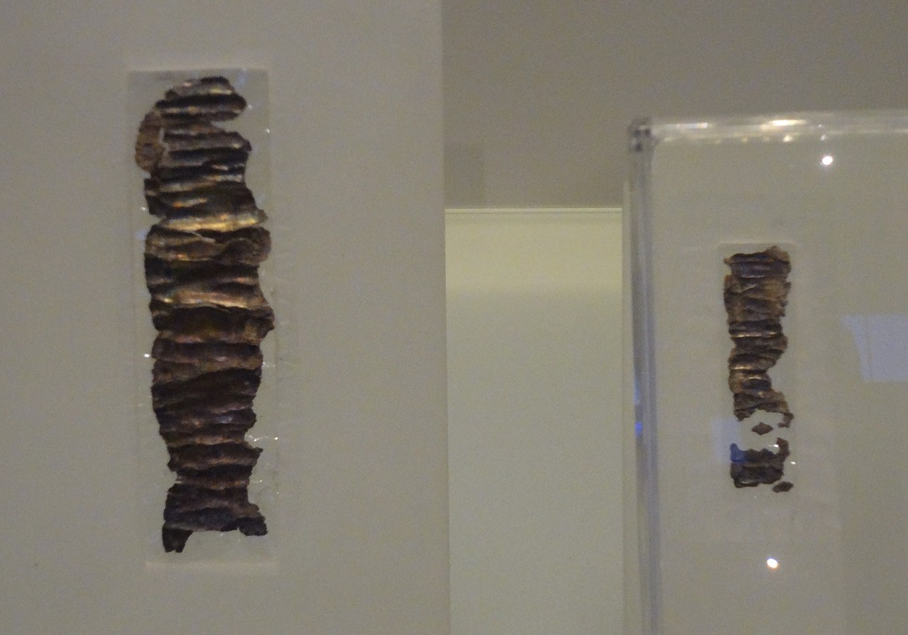
https://en.wikipedia.org/wiki/Ketef_Hinnom
Enhancements
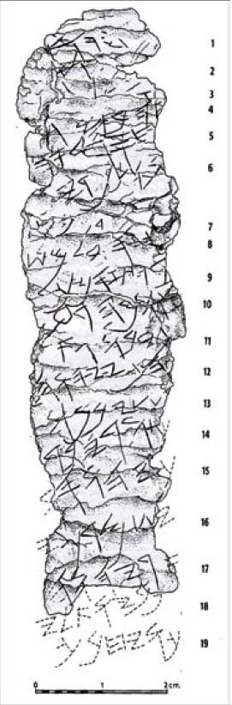
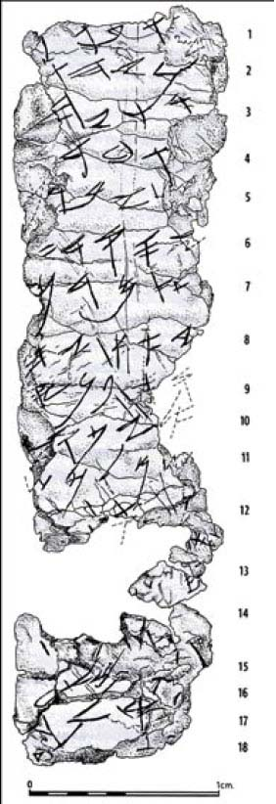
Because these photographs are impossible to read, we also included photographs that were enhanced by modern photographic techniques and computer imaging technology. The character impressions are now legible: so, you can see what the engraving actually looks like. It is very clearly paleo-Hebrew script.
http://www.biblearchaeology.org/post/2010/01/06/The-Blessing-of-the-Silver-Scrolls.aspx
Contrast
Contrast what you see in the representations of the artifacts, with the block Aramaic style of Hebrew text below, which is similar to the text found in printed Hebrew Bibles. The sample is the Great Shema.
Quote:
שְׁמַ֖ע יִשְׂרָאֵ֑ל יְהוָ֥ה אֱלֹהֵ֖ינוּ יְהוָ֥ה׀ אֶחָֽד׃
וְאָ֣הַבְתָּ֔ אֵ֖ת יְהוָ֣ה אֱלֹהֶ֑יךָ בְּכָל־לְבָבְךָ֥ וּבְכָל־נַפְשְׁךָ֖ וּבְכָל־מְאֹדֶֽךָ׃
וְהָי֞וּ הַדְּבָרִ֣ים הָאֵ֗לֶּה אֲשֶׁ֨ר אָנֹכִ֧י מְצַוְּךָ֛ הַיּ֖וֹם עַל־לְבָבֶֽךָ׃
וְשִׁנַּנְתָּ֣ם לְבָנֶ֔יךָ וְדִבַּרְתָּ֖ בָּ֑ם בְּשִׁבְתְּךָ֤ בְּבֵיתֶ֙ךָ֙ וּבְלֶכְתְּךָ֣ בַדֶּ֔רֶךְ וּֽבְשָׁכְבְּךָ֖ וּבְקוּמֶֽךָ׃
וּקְשַׁרְתָּ֥ם לְא֖וֹת עַל־יָדֶ֑ךָ וְהָי֥וּ לְטֹטָפֹ֖ת בֵּ֥ין עֵינֶֽיךָ׃
וּכְתַבְתָּ֛ם עַל־מְזוּזֹ֥ת בֵּיתֶ֖ךָ וּבִשְׁעָרֶֽיךָ׃
Unquote.
Here is another example of the problem:

Phoenician | paleo-Hebrew | Samaritan | square Hebrew | English name
 |  | ࠀ | א | Aleph
 |  | ࠁ | ב | Bet
 |  | ࠂ | ג | Gimel
 |  | ࠃ | ד | Dalet
 |  | ࠄ | ה | He
 |  | ࠅ | ו | Waw
 |  | ࠆ | ז | Zayin
 |  | ࠇ | ח | Heth
 |  | ࠈ | ט | Teth
 |  | ࠉ | י | Yodh
 |  | ࠊ | כ/ך | Kaph
 |  | ࠋ | ל | Lamedh
 |  | ࠌ | מ/ם | Mem
 |  | ࠍ | נ/ן | Nun
 |  | ࠎ | ס | Samekh
 |  | ࠏ | ע | Ayin
 |  | ࠐ | פ/ף | Pe
 |  | ࠑ | צ/ץ | Tsade
 |  | ࠒ | ק | Qoph
 |  | ࠓ | ר | Resh
 |  | ࠔ | ש | Shin
 |  | ࠕ | ת | Taw

https://en.wikipedia.org/wiki/Paleo-Hebrew_alphabet
Even though we are not professional epigraphers, we can easily see that the engravings on the silver scrolls look a lot more like paleo-Hebrew, than square Hebrew.
Translation
KH1
According to this interpretation, the larger silver scroll, the one pictured on the left, technically named, KH1…
Quote:
KH1 (27 × 97 mm; 1.0 × 3.75 inches)
[Top line(s) broken]
1. ...] YHW ... 2. [...] 3. the grea[t ... who keeps] 4. the covenant and 5. [G]raciousness towards those who love [him] and (alt: [hi]m;) 6. those who keep [his commandments ... 7. ...]. 8. the Eternal? [...]. 9. [the?] blessing more than any 10. [sna]re and more than Evil. 11. For redemption is in him. 12. For YHWH 13. is our restorer [and] 14. rock. May YHWH bles[s] 15. you and 16. [may he] keep you. 17. [May] YHWH make 18. [his face] shine ...
[Bottom line(s) broken.]
Compare lines 3-6 to:
Exodus 20:6 – showing mercy to thousands of them that love Me and keep My commandments
Deuteronomy 5:10 – showing mercy to thousands of them that love Me and keep My commandments
Deuteronomy 7:9 – keeping covenant and mercy with them that love Him and keep His commandments to a thousand generations
Daniel 9:4 – keeping covenant and mercy to them that love Him, and to them that keep His commandments
Nehemiah 1:5 – keeping covenant and mercy for them that love Him and observe His commandments
The omission of “thousands” may have originally appeared on line 7 as in Deuteronomy 7:9.
Unquote.
Note: lines 14-18 seem much more like Numbers 6:24-26.
KH2
According to this interpretation, the smaller silver scroll, the one pictured on the right, technically named, KH2…
Quote:
KH2 (11 × 39 mm; 0.5 × 1.5 inches)
[Top line(s) broken]
1. -h/hu. May be blessed h/sh- 2. -[e] by YHW[H,] 3. The warrior/helper and 4. the rebuker of 5. [E]vil: May bless you, 6. YHWH, 7. keep you. 8. Make shine, YH- 9. -[W]H, His face 10. [upon] you and g- 11. -rant you p- 12. -[ea]ce.
[Bottom line(s) broken.]
Compare lines 5-12 to Numbers 6:24-26:
- [lines 5-7] 6:24 Yahweh bless you and keep you;
- [lines 8-9] 6:25 Yahweh make his face shine upon you, and be gracious to you;
- [lines 10-12] 6:26 Yahweh lift up his countenance upon [you], and give you peace.
(Note that the two bold italicized phrases above are not present on this scroll; also note that all of Numbers 6:25-26 may have appeared on KH1 after line 18 where the scroll has disintegrated).
Unquote.
The article in Bible and Spade magazine, “The Blessing of the Silver Scrolls”, by Stephen Caesar, Jan 06, 2010, is well worth the readers detailed attention.
Conclusions
While the stories of discovery, unraveling, and special technical examination are intriguing, even fascinating, they are not the main point. The main point is that we have the evidence to read. On the other hand, we would not have reached readable evidence without all of the steps that preceded reading, translation, and the dawning of realization.
The dating for the silver scrolls is not as early as we had hoped; yet, certainly prior to 586 BC (pre-exilic): we would be much happier with a date of 700 BC. We are in desperate need of more evidence of this type, from everywhere in the 1010-586 BC range. Were any of the ancient documents ever recorded on clay tablets? We may never know.
What we do know is that quotes of what we now know as Numbers 6:24-26 exist and were extant prior to 586 BC. Moreover, these quotes seem to be mixed with quotes from Deuteronomy: however, this is confounded by the numerous other texts that quote from Deuteronomy, so Deuteronomy may not be directly engaged. Nevertheless, because of Josiah, Deuteronomy is most likely in play during this era. Thus, we have a text that does not come exclusively from Deuteronomy, making it much less likely that only Deuteronomy was found in Josiah’s temple search.
There are two distinct, 50/50, possibilities related to sources. One, Numbers 6:24-26 is the source, known from oral or other tradition: the rest of Numbers was invented, being written around Numbers 6:24-26 and other key sources circa 500 BC. Or, if you still cling to J: J was invented, being written around Numbers 6:24-26 circa 950 BC. Two, the entire book of Numbers is the source, written by Moses (1406-1364 BC), possibly in the Akkadian language, possibly on clay tablets: Numbers 6:24-26 is a quote from Numbers, the source document. You decide which of these is the most likely possibility.
So, the claim that “the silver scrolls confirm that the Hebrew Bible is created from poetry, oral traditions, and prayers that go back to the time of Josiah’s D writer, and likely beyond to writers, E and J,” is completely bogus. This claim is an opinion about statistical probabilities for which we have no evidence; which we cannot measure; nor can we calculate such probabilities. The only further weight of evidence, is whether we are to believe that such supposed oral traditions can be retained, with detailed accuracy, over such great spans of time: for such memory retention, does not exist in modern times. The oral tradition hypothesis requires, not only that Numbers 6:24-26 be retained in memory, but also that all of the key passages be retained in memory: which is a far more difficult task. Some claim memorization of a complete oral Torah, without alteration, for a span of over one-thousand years.
God forsook the Jews because they had sinned against Him, as He repeatedly warned them. There has never been any doubt about this issue. There is plenty of evidence outside of Torah that makes this point abundantly clear.
Any claim that the Jews lost because Yahweh was weaker than the idols of Babylon is contradicted by the evidence, by the facts. Everything that Nebuchadnezzar attempts must be run by Daniel or other Jews: his dream statue, his golden statue, his furnace, his sanity, his grandson’s use of goblets, the termination of Babylon. It never was a question of power.
While the Jews abandoned clay figurines, they retained the right to worship after the form of their own hearts. They only appear to “abandon the folly of polytheism”.
The Jews did not invent their “concept of God as it is known today”. Rather, God created them.
There is no resonance between any of the world’s great religions. Their expressions about God are completely different. They continue to wage war with each other. We have not forged our swords into plowshares; instead we have made our lips into flamethrowers, and our tongues into automatic rifles… our eyes shoot out hatred… our hearts breath out violence… peace, peace, there is no peace. We live in armed camps protected by heavy walls.

The odds are about 50/50; flip a coin; it’s one opinion against another opinion, with insufficient evidence to find resolution, or calculate more accurate probabilities. One-hundred pieces of evidence scattered randomly over the period from 1000-586 BC might provide enough data. Best of all, would be the discovery of a complete Torah recorded on clay tablets in Akkadian Cuneiform, and firmly dated to 1406-1364 BC. You should be able to see that we are grasping at straws, considering how little archaeological evidence we truly have. The Bible, however, provides its own evidence, which is often ignored.
Even if personal, Ein Sof is not reconcilable with Trinity. The false Islamic claim, Christianity teaches that Mary is a member of the Trinity, is not unifying either. With such vast differences concerning God, differences in authority structure, and ongoing bloodshed: it is unrealistic to expect any kind of resonance any time soon.
http://en.wikipedia.org/wiki/Ketef_Hinnom
phylactery or tefillin?
Andrew G. Vaughn, epigrapher at American Schools of Oriental Research. Works: Tel Miqne (1994), Ashkelon (1995), Megiddo (1996), Beth Shemesh (1994 …), Ramat Rahel (1996 …). http://homepages.gac.edu/~avaughn/
So, according to the narrator, a Judean, had inscribed Numbers 6:24-26 on a valuable silver sheet and rolled it into an amulet, during the time of Josiah (649-609 BC). (For the facts of the matter, pictures are included in the main discussion below.) This, if true, would prove that Numbers 6:24-26 was extant, being an item of intense interest in the seventh-century BC: not just Deuteronomy (600 BC) alone; the Judeans had discovered more than Deuteronomy in the temple. If the hypothesis for Deuteronomy is accepted (only for the sake of argument), this would prove that which had only recently been written on the scroll, or that which had not yet been written on the scroll was displaced from Deuteronomy: for the standard claim is that only Deuteronomy was found: J, E, and D would not be assembled until circa 500 BC. So, the P assembly hypothesis (500 BC) is wrong, at least in this instance, hence in all probability wrong overall: for this amulet could not have been created in a vacuum… it was at least half as likely to have been quoted from part of a larger corpus. (the narrator would lead us to believe that the silver scroll was the basis for inventing the larger corpus; rather than being a brief quote from the larger corpus.) So, at least in part, the Documentary Hypotheses are wrong: those who are inclined to believe such rot, must write a new hypothesis to explain and include this evidence. Why is this so? Because the Bible is its own evidence; given a 50/50 chance from external evidence: the Bible deserves the benefit of the doubt. Moreover, the issue of whether Deuteronomy was discovered or merely created on the spot to keep Josiah happy, comes into play. If created to keep Josiah happy, we would still have to push the D date back to 650, not 600 BC: how could the best of scribes pull this off without being caught. If truly discovered, we would have to push the D date further back to 700 BC or earlier. The whole logical construct of the Documentary Hypotheses is crumbling to pieces before our very eyes. On the other hand, Numbers 6:24-26 is not exactly an accurate representation of what the scrolls record as the narrator suggests. So, BBS has confronted us with another smokescreen without a true disclosure of the facts: https://en.wikipedia.org/wiki/Ketef_Hinnom http://www.biblearchaeology.org/post/2010/01/06/The-Blessing-of-the-Silver-Scrolls.aspx Nevertheless, the bulk of our argument must stand. All the dates must be revised. The Bible’s own story of such scrolls is that they are probably phylacteries (tefillin), cult objects worn on the person of the seriously observant in literal obedience to Deuteronomy 6:8. So how is it that portions of the well-known Numbers 6:24-26 benediction came to be embedded in portions of the equally well-known, “Great Shema” (Deuteronomy 6:4-9)? Especially, if they are written hundreds of years apart: if P, 500-600 = 100 years; if E, 850-600 = 250 years; if J, 950-600 = 350 years; if Moses, 1364-600 = 764 years apart ?? ? #
The calligraphy is clearly that of paleo-Hebrew known to be in use from circa 1000-586 BC, after which it begins to be displaced by the Block Aramaic script we call Hebrew. There is even evidence that paleo-Hebrew existed in parallel with Hebrew after 516 BC. The ability to reduce these two amulets to the seventh century, based on calligraphy, requires such epigraphy skills as to, not only read, and identify the script family; but also, requires the ability to distinguish individual hand writing styles by date: no small trick….
Because of their lack of provenance, the Dead Sea Scrolls are a non-starter.
This is a very Existential, blind leap of faith. The silver scrolls confirm no such thing: they confirm nothing about basis in “poetry, oral tradition, and prayers” that precede the surrounding prose narrative environment. The narrator simply presumes the conclusion he/she desires to prove (begging the question). The silver scrolls confirm only that the Mosaic benediction was extant in this form in the seventh century. They confirm nothing about the origins of such a form. Statistically, we would be forced to conclude that such evidence provides no good reason to reject the hypothesis that the entire Torah was written by Moses between 1406 and 1364 BC: hence the minimally 50% probability, based only on the silver scrolls, that Torah was written by Moses between 1406 and 1364 BC. We would also be forced to conclude that no good reason exists to reject any hypothesis that J, E, D, or even P were written before the seventh century. What we are forced to reject is any hypothesis that J, E, D, or Torah are completely written (but not in part) after the seventh century, because we have an extant piece of J, E, D, and Torah clearly dating from the seventh century. P is only excluded from this statistic in so far as P is said to exclude this passage.
This leaps immediately to an unwarranted conclusion. What modern scholars suspect [rather, what they conjecture] is irrelevant to the case at hand: namely two tiny silver scrolls and what they establish beyond doubt. They establish the possibility that at least the Torah could have been written before the seventh century, and cast doubt on the idea that any of the Torah was written after the seventh century. In either case, the two scrolls establish only necessary conditions, but not the sufficient conditions for a full proof.
N. B., the pictures associated here are not completely authentic. None of the Babylonian artifacts exist any longer. The pictures are of a reconstruction of the Ishtar gate, not the original. http://en.wikipedia.org/wiki/Ishtar_Gate
There is no fundamental question. The Judean prophets made the point painfully clear: as with the time of Eli, when Yahweh forsook them the first time; yet, this time, with even greater intensity. Yahweh assured the Judeans, in no uncertain terms, that they were being punished for the multitude of their sins, primarily idolatry. This was not a cover story invented in 500 BC: Elijah (earlier ninth-century BC), Elisha (later ninth-century BC), Jonah (late ninth to early eighth-century BC), Hosea (mid eighth-century BC), Amos (mid eighth-century BC), Isaiah (late eighth to early seventh-century BC), all warned them. Israel’s certain doom (722 BC) was contrasted to Judah’s impending doom (586 BC). Prophets spoke to Judea, right down to the wire (586 BC); but, Judea did not listen… their lying prophets did not listen (Jeremiah 18:1-23; 23:25-40; 37:1-21; Ezekiel 4:1-17; 17:1-24). After seventy years, they would return (Jeremiah 25:11-12; 29:10; Daniel 9:2; Zechariah 7:1-14). For there to be a fundamental question; for the Documentary Hypotheses to be true; lying prophets and scribes would have had to fabricate Torah, and invent all the words of these prophets without making a mistake… that would be a statistically unlikely coincidence. What reason would they have to invent all these prophets and cross reference them in such detail? How did they concoct such an enormous lie, a fraud, in so few years, without getting caught? https://www.swrktec.org/jonah
Coogan has captured the pagan mentality. He has not captured the Divine providence. As the truth unfolded, the Jews eventually realized that history was marching relentlessly ahead, exactly as Yahweh said it would. As the truth unfolded in an irrefutable way, the Jews were brought to a partial, if somewhat insincere, and reluctant repentance: otherwise it was business as usual with adultery, mixed marriages, and the like. This Jewish tenacity did not bring the Jews to repentance; Yahweh confronted them with overwhelming truth; their continuing tenacity still raged against God. This Jewish tenacity, in and of itself, establishes, at the very least, that the Israelites possessed an experience of God that involved quite a bit more than figurines, monuments, or statues of any size: things that were made by men from clay, cloth, metals, stone, wood, or other materials. For the Jews, materials were to be used for Temple adornments, and decorations; yet, God was unlike any of these, and God was heard to speak from the Oracle. God was not the clay: God was the Voice. The punishment was harsh, but the Jews could not get past the evidence from the Oracle.
Which is it? Did Yahweh fail because He was weaker than pagan idols? Or, did Yahweh just abandon them? Coogan and Machinist cannot have it both ways. Yes, the Jews “must have done something wrong”; and that something was spelled out in bloody detail. Nebuchadnezzar was not the representative of an alternate higher power, an idol; he was Yahweh’s stated rod of punishment… the prevailing Divine instrument. Even Egypt would fail against this unbreakable instrument of the wrath of God.
They are not Israelites, they are Jews. There is evidence of strong tribal jealousy between the two tribal groups, the Joseph tribes and the Judah tribes; so, why is it necessary for the Jews to invent a fictitious people to bolster their own national identity? Why bother with the invention of Israelites if the defense of Judean nationality from 1000 to 586 BC is all that is at stake?
Ephraim Stern (1934 …), an Israeli archeologist with the Hebrew University of Jerusalem. Works: Massadah, Hazor, Tel Be’er Sheva, Tel Mor, En Gedi, Gilam, Tel Kadesh, Tel Mevorakh, Tel Dor. http://en.wikipedia.org/wiki/Ephraim_Stern
Rubbish, “the concept of God as it is known today”, was born with Adam, Eve, and their children; confirmed by Noah and his family; advanced under Abraham, Sarah, Lot, and Terah; blossoming into the tribes of Israel, about the time of Moses. Is the claim of Levine or of the narrator supported by Mishnah, Talmud, or Halakha? Where is the source authority for this wondrous invention?
How, on earth, does McCarter leap from the silver scrolls to a conclusion about P?
Without doubt, Yahweh is “God of the world, the God of the universe”; but, not because P says so… because Yahweh says so.
We now see where this discussion has been headed all along. Meyers would have us believe that when Christians, Jews, and Mohammedans speak of God they are all talking about the same thing: which, is not at all true. We’re not even sure that all Christians have the same ideas about God. In any case, there is no resonance with all people. If such a resonance were ever to develop, our many global wars would cease. To the shame of Christendom, Christians now seem to have perpetrated more wars than anybody else. If such a resonance were ever to develop, there would be widespread agreement about matters of faith, instead of the strife based on falsehood that BBS has been trying to spread on public television, and through other media.
https://en.wikipedia.org/wiki/Paleo-Hebrew_alphabet
Deuteronomy 6:4-9, as well as Deuteronomy 4:1; 5:1; 6:3; 9:1; 10:12; 20:3; 27:9
https://en.wikipedia.org/wiki/Ketef_Hinnom
ibid
http://www.biblearchaeology.org/post/2010/01/06/The-Blessing-of-the-Silver-Scrolls.aspx
or even Exodus in one instance.
If you have been blessed or helped by any of these meditations, please repost, share, or use any of them as you wish. No rights are reserved. They are designed and intended for your free participation. They were freely received, and are freely given. No other permission is required for their use.

